Alexander Taniguchi(Wiegman)  
08-174510

Homework Week 3: Database SQL with My Courses

Logic

The assignment is to make a database of my courses and show a few sample operations on such a database. This means I need to adopt a workflow of “create table” 🡪 (sample) “row operations” with table 🡪 (sample) “query of data” from table. A few samples of each will be given, complete with explanations of what this would correspond to in ‘real everyday life’.

The first step is to initialize a table, we can use the following command to make a new database file in memory, such as ‘courses.db’.

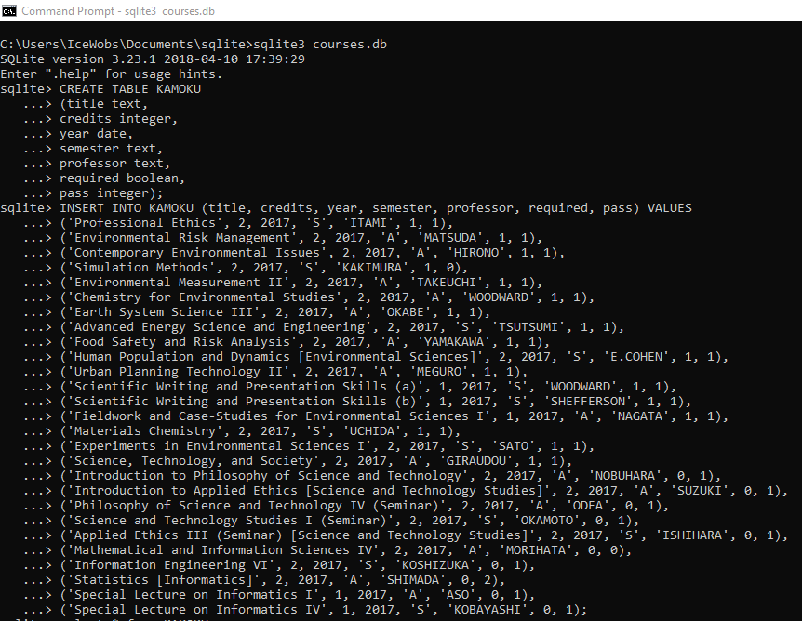

Then, I should create the table of values. We should define the names of each column and what sort of data-type each of those columns will be. We may, and should, close all commands with the ‘;’.



In this table, I have created the columns for the ‘course TITLE’ as the ‘name’, ‘CREDITS obtained’ as an integer, ‘YEAR course was taken’ as a date, ‘SEMESTER course was taken (summer or autumn)’ as a one-letter ‘s’ or ‘a’ textual representation, ‘PROFESSOR teaching the course’ using their ‘LAST_NAME’, ‘REQUIRED course or elective’ as ‘BOOLEAN’ value (0 is elective, 1 is required for major), and ‘PASS’ as an integer representation where 0 is not pass (fail), 1 is pass, and 2 is “didn’t sit exam / drop / other”.

Next, we must initialize all the values for the table.



This ends up looking like:

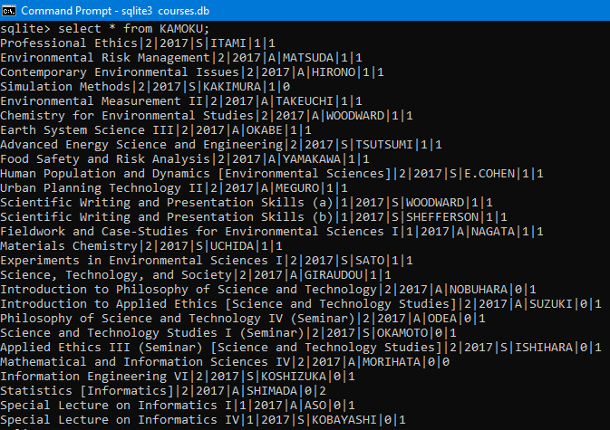

With this simple table, we will now move out of logic and into usage.

Usage

*Row Operations*

With the simple table created above, we may try some operations such as adding my current classes for this semester (with grading value integer of “2” as they are not pass nor fail), or dropping one of the added courses because ~~I no longer want to take this database course~~ (a joke, please forgive me).

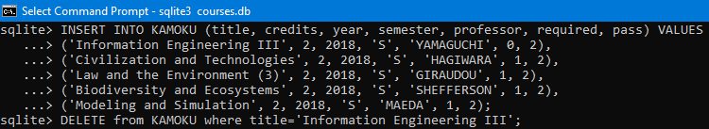

Please note that I still plan on attending this course, this is just an example.

We’ve seen the INSERT command already above, it will help us to add courses.  
Meanwhile, the DELETE command will delete tuples WHERE some condition is defined.

After this change, we may notice that there are some extra courses in the table now.

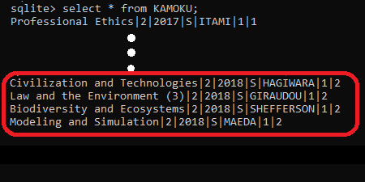

More conspicuously, we notice that “Information Engineering III” (database) course is no longer listed.

As changing the order of listing is not important in the real-life case of one’s courses taken, this will conclude the row operations.

*Querying Data from the Table*

To query data from the table is to choose a desired condition, and then ask the database to only return a partial set of the whole which matches this condition.

The most elementary condition (after a trivial ‘select nothing’) would be one that we have used ample times before in this assignment. ‘Select *’ (wildcard symbol for ALL) entries of table.

But, when we are looking at our grades, we should consider things like “which courses have I not passed”, “what did I take in 2017A semester”, and “select and order all classes I am currently taking in alphabetical order of professor’s last name”. I will look at these three questions in the following part of this assignment.

* Which course(s) have I failed in 2017 (i.e. that I am not currently taking)?

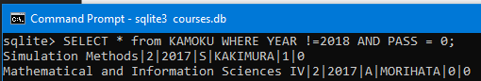

I’m very sorry to these professors as both times were my fault (not studying enough for the exam, and not finishing one of three large assignments; respectively).

* Which course(s) did I take in 2017A semester?

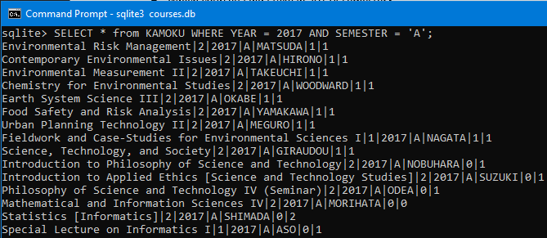

In all, I took the above 15 courses. It was a busy semester.

Fun fact, I’m taking much less this semester.

(Mostly because I became sick during registration period, I’m adding a few more this week if professors will still take me.)

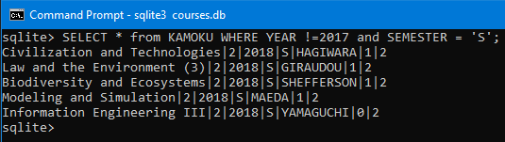

* “Select and order all classes I am currently taking in alphabetical order of professor’s last name”?

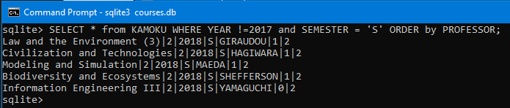

Giraudou 🡪 Hagiwara 🡪 Maeda 🡪 Shefferson 🡪 Yamaguchi is indeed alphabetical order, and the five professors who teach courses I am attending this semester.

Now, let’s make this fun and add an extra sub-command to only output the professors and course title.

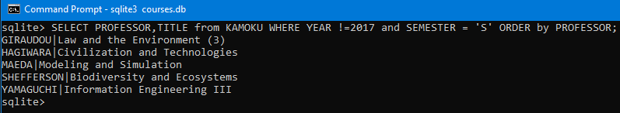

Yep, there is no doubt that this is a powerful set of commands that SQL can provide us.

*Additional: Garbage Data Creation and Deletion (‘DROP TABLE’ usage-case)*

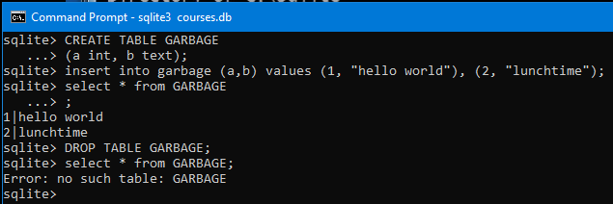

I made a table of garbage, decided it was not needed and deleted it.

The PDF version of this assignment has the database file that SQLITE3 output for me attached to it.

*(End of Week 3 Assignment, Problem 25 from Week 2 Handout)*